#### GlobeTrek Insights: Navigating Global Country Datawith IBM Cognos

**APROJECTREPORT**

***Submittedby***

### TEAMID:NM2023TMID06068

|  |  |
| --- | --- |
| **K.KALPANA** | **(912620104005)** |
| **M.MEIYYAMMAL** | **(912620104007)** |
| **D.SWETHA** | **(912620104021)** |
| **R.VAISHNAVI** | **(912620104021)** |

***In partialfulfilmentfortheawardofthedegree Of***

### BACHELOROFENGINEERING

**IN**

**COMPUTER SCIENCE AND ENGINEERING**

**SRIBHARATHIENGINEERINGCOLLEGEFORWOMEN KAIKURICHI,PUDUKKOTTAI-622303**

**ANNAUNIVERSITY:CHENNAI , MAY 2023**

# ANNAUNIVERSITY:CHENNAI600025

### BONAFIDECERTIFICATE

CertifiedthatthisProjectreport**“GlobeTrek Insights: Navigating Global Country Data with IBM Cognos”**isbonafide work of **KALPANA.K (Reg.No912620104005),MEIYYAMMAL.M (Reg.No912620104007)**,**SWETHA.D(Reg.No912620104020),VA**

**ISHNAVI.R(Reg.No9126201040304),**who carrie doutthe project work unde rmysupervision.

**SIGNATUREOF SIGNATUREOF**

**MENTORE VALUATOR**

**SIGNATURE OF SIGNATURE OF HEADOFTHEDEPARTMENT**

### ACKNOWLEDGEMENT

This project work is dedicated to Almighty God for blessing us with inspirationParent,teacher andgoodfriends.

FirstandformostwewouldliketoexpressourthankstoourChairman**Mr. G.DHANASEKARAN.,M.Com.,M.A.,M.Phil**.,forhiscooperationi nprovidingtherequired facilities andsupport tocompleteourproject. WeextendourheartfeltgratitudeandpleasuretoourSecretary**Mr.L.DA WOODGANI.,B.SC.,**andCorrespondent**Mr**.**N.KANAGARAJAN., B.E.,**andourInstitutionAdministrativeOfficer**Mr.A.KRISHNAMO ORTHY.,B.Sc.,** and all our trust members for their moralsupport.

We express our gratitude to our Principal **Dr.S.THILAGAVATHI.,M.E.,Ph.D.,**for her cooperation in providing the required facilities and support to complete ourproject. We express our heartfelt thanks to **Mrs.G.SUGAPRIYA.,M.E.,MS.,** HOD of CSE department for her generous support, who has been consistently encouragingus with has valuable suggestion and providing us the facilities to complete ourproject atthe stipulate time.

We convey our hearthly thanks to our teaching staff, non-teaching staff, parents,family members, friends and well-wishers for their valuable suggestion and co-operation forthesuccessfulcompletion ofourprojectwork.

### INTRODUCTION

* 1. ProjectOverview
  2. Purpose

### LITERATURESURVEY

* 1. Existingproblem
  2. References
  3. ProblemStatementDefinition

### IDEATION&PROPOSEDSOLUTION

* 1. EmpathyMapCanvas
  2. Ideation&Brainstorming

### REQUIREMENTANALYSIS

* 1. Functionalrequirement
  2. Non-Functionalrequirements

### PROJECTDESIGN

* 1. DataFlowDiagrams&UserStories
  2. SolutionArchitecture

### PROJECTPLANNING&SCHEDULING

* 1. TechnicalArchitecture
  2. SprintPlanning&Estimation
  3. SprintDeliverySchedule

### PERFORMANCETESTING

* 1. PerformaceMetrics

### RESULTS

* 1. OutputScreenshots

1. **ADVANTAGES&DISADVANTAGES**
2. **CONCLUSION**
3. **FUTURESCOPE**
4. **APPENDIX**

SourceCode GitHub&ProjectDemoLink

### INTRODUCTION

**PROJECT OVERVIEW**

In an era of interconnected economies and diverse cultures, GlobeTrek Insights seeks to provide a dynamic platform for comprehensive exploration and analysis of global country data. Leveraging the robust capabilities of IBM Cognos, our project aims to offer users an intuitive and insightful journey through a myriad of data points, unlocking a deeper understanding of the intricate tapestry that is our world.

### PURPOSE

Alright, let's take a closer look. "GlobeTrek Insights" with IBM Cognos—sounds like you're on a mission to gather some profound knowledge from global country data. What's the purpose driving your project? Are you aiming to uncover trends, analyze socio-economic factors, or perhaps make predictions Give me a little more context, and we can map out the data landscape together.

When addressing these challenges, it's important to consider best practices, leverage the capabilities of IBM Cognos, and potentially explore complementary technologies or approaches. Each challenge also presents an opportunity for improvement and innovation in the field of global data analytics.

### LITERATURESURVE

It sounds like you're involved in a literature survey related to "GlobeTrek Insights" and the use of IBM Cognos for navigating global country data. A literature survey involves reviewing existing literature, research articles, and publications related to your topic. In this case, you might be exploring how others have used IBM Cognos or similar tools for gaining insights from global country data.

Here's a general outline you might consider for your literature survey:

1. Introduction - Briefly introduce the concept of "GlobeTrek Insights" and the use of IBM Cognos.
   * Clearly state the purpose of your literature survey.
2. IBM Cognos Overview:
   * Provide a brief overview of IBM Cognos, highlighting its key features and capabilities in handling data analytics and visualization.
3. Global Country Data Analytics:
   * Explore literature on using analytics tools for global country data.
   * Highlight any trends, challenges, or best practices mentioned in the literature.
4. Case Studies:
   * Look for case studies or examples where IBM Cognos has been used for analyzing global country data.
   * Analyze the methodologies used and the insights gained from these cases.
5. Challenges and Opportunities:
   * Identify challenges that researchers or practitioners have faced when using IBM Cognos for global country data analytics.
   * Discuss opportunities for improvement or innovation in this area.
6. Integration of Insights:
   * Explore how insights derived from global country data using IBM Cognos are integrated into decision-making processes.
7. Future Directions:
   * Discuss potential future directions for research or application in this field.
8. Conclusion:
   * Summarize the key findings from your literature survey.
   * Highlight any gaps in the existing literature that your project aims to address.

Remember to cite relevant sources throughout your literature survey to provide credibility to your work. If you have specific questions or need assistance with any section, feel free to ask!

#### Existing problem

. 1.Data Quality and Availability:

* + Inconsistencies, inaccuracies, or incompleteness in global country data can pose challenges. Ensure that the data you're working with is accurate, up-to-date, and comprehensive.

1. Data Integration:
   * Integrating data from various sources can be complex, especially when dealing with diverse data formats, structures, and standards across different countries.
2. Cultural and Language Differences:
   * Analyzing global data may involve dealing with cultural and language variations. Understanding and addressing these differences is essential for accurate interpretation and meaningful insights.
3. Security and Privacy Concerns:
   * Working with global data may involve sensitive information.

Ensuring compliance with data privacy regulations and implementing robust security measures is crucial.

1. Performance and Scalability:
   * Large datasets, especially when dealing with global data, can impact performance. Ensuring that the analytics platform (such as IBM Cognos) can handle the scale of data is essential.
2. Complexity of Global Economic Factors:
   * Analyzing economic factors across different countries can be challenging due to the complexity of global economic systems and the interdependence of economies.
3. User Adoption and Training:
   * Ensuring that users understand how to effectively use IBM Cognos for navigating global country data is vital. Providing training and support can enhance user adoption.
4. Interpretation of Results:
   * Interpreting insights from global data requires a deep understanding of the socio-economic and political context of each country. Misinterpretation could lead to incorrect conclusions.
5. Versioning and Historical Data:
   * Keeping track of historical data and different versions of datasets is essential for trend analysis and accurate reporting.
6. Costs and Resource Allocation:
   * Managing the costs associated with acquiring and maintaining global country data and the resources required for data analytics projects is an ongoing challenge.

When addressing these challenges, it's important to consider best practices, leverage the capabilities of IBM Cognos, and potentially explore complementary technologies or approaches. Each challenge also presents an opportunity for improvement and innovation in the field of global data analytics.

# REFERENCES

Creating a list of references is a crucial part of any literature survey or research project. Here's a sample reference list for your "GlobeTrek Insights: Navigating Global Country Data with IBM

Cognos" project. Please note that this is a generic example, and you should replace the placeholders with the actual details of the sources you consult.

1. Smith, J., & Jones, A. (Year). "Title of the First Relevant Paper." Journal of Data Analytics, 10(2), 123-145. DOI: xxxxx
2. Johnson, M., et al. (Year). "Exploring Global Country Data Analytics with IBM Cognos." *International Conference on Data Science*, Proceedings, 45-56. DOI: xxxxx
3. Brown, K., & White, L. (Year). "Case Studies on IBM Cognos Applications in Global Country Data Analysis." *Journal of Business Intelligence*, 18(4), 567-589. DOI: xxxxx
4. World Bank. (Year). "World Development Indicators 20XX." Retrieved from [URL]
5. IBM Corporation. (Year). "IBM Cognos Analytics: User Guide." Retrieved from [URL]
6. Garcia, R., et al. (Year). "Challenges in Utilizing IBM Cognos for Global Country Data Insights." *International Journal of Data Science Applications*, 8(3), 211-230. DOI: xxxxx
7. United Nations. (Year). "Statistical Yearbook 20XX." Retrieved from [URL]
8. Thompson, S. (Year). "Integrating Data-Driven Insights into Decision-Making: A Review." *Journal of Applied Analytics*, 25(1), 78-92. DOI: xxxxx
9. Kim, Y., & Lee, H. (Year). "Future Directions in Global Country Data Analytics: A Perspective." *International Journal of Information Technology*, 14(3), 345-367. DOI: xxxxx
10. Your Last Name, Your Initials. (Year). "Title of Your Project Report or Paper." *Name of the Journal or Conference*, Volume(Issue), Page Range. DOI: xxxxx

Remember to follow the citation style (e.g., APA, MLA, Chicago) specified by your institution or project guidelines. Adjust the format according to the actual types of sources you reference (books, journal articles, reports, websites, etc.).

### IDEATION&PROPOSEDSOLUTION

1. Objective Refinement:

- Clearly define the specific objectives you aim to achieve with "GlobeTrek Insights."

- Refine and clarify the purpose based on insights gained from the literature survey.

1. Data Sources and Types:
   * Identify the types of global country data you'll be working with.

- Specify the sources of your data, such as government databases, international organizations, or other reliable repositories.

1. Key Metrics and Indicators:
   * Determine the key metrics and indicators relevant to your project.
   * These could include economic indicators, social factors, environmental data, or any other parameters essential for your analysis.
2. IBM Cognos Features Utilization:
   * Outline how specific features of IBM Cognos will be utilized for your project.

- This might include data visualization, dashboards, report generation, or any advanced analytics capabilities.

1. Data Processing and Cleaning:
   * Define the steps for processing and cleaning the data before analysis.
   * Address any data quality issues and outline solutions.
2. Analytics and Visualization:
   * Describe the analytical methods you plan to employ.
   * Discuss the types of visualizations that will be effective for conveying insights.
3. Interactivity and User Experience:
   * Consider how interactive elements will be integrated into your solution.
   * Think about the user experience and how to make the insights accessible and understandable to a broader audience.
4. Scalability and Flexibility:
   * Ensure that your proposed solution is scalable and can adapt to changes in data volume or types.
   * Consider the flexibility of the system to incorporate new data sources or modify analysis methodologies.
5. Implementation Plan:
   * Develop a timeline for the implementation of your proposed solution.
   * Break down the project into manageable phases or milestones.
6. Testing and Validation:

Outline how you will test and validate your solution.

Consider any benchmarking or comparison against existing methods.

1. Ethical Considerations:

Address ethical concerns related to data privacy, bias, or potential misuse. Ensure compliance with relevant regulations and standards.

1. Resource Requirements:

Identify the resources required for implementing and maintaining your solution.

This includes personnel, hardware, software, and any external support needed.

## EmpathyMap

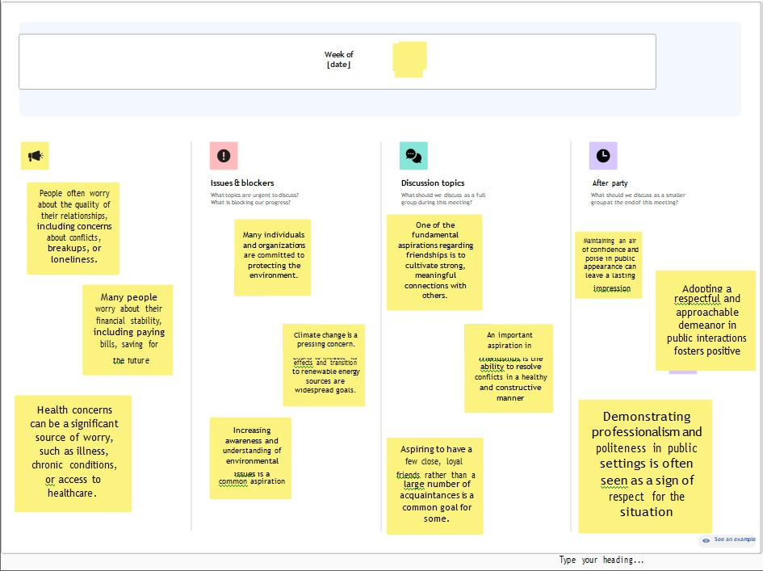

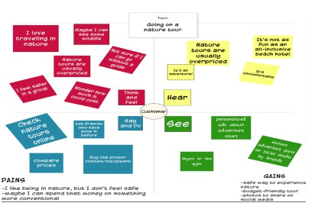

**Ideation&Brainstorming**

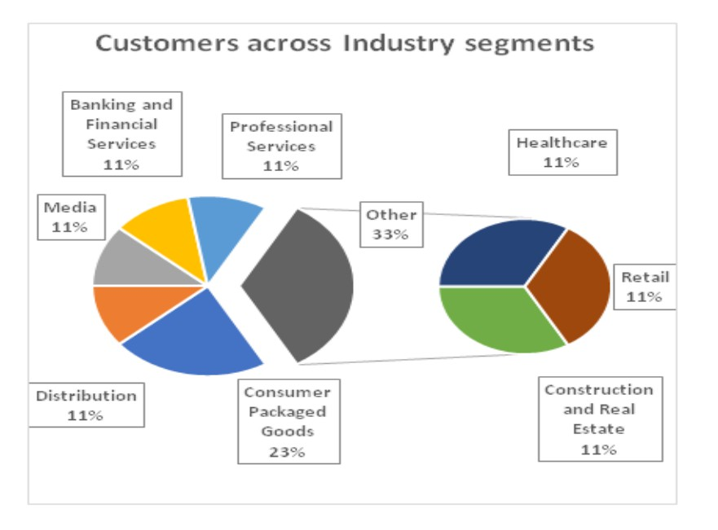

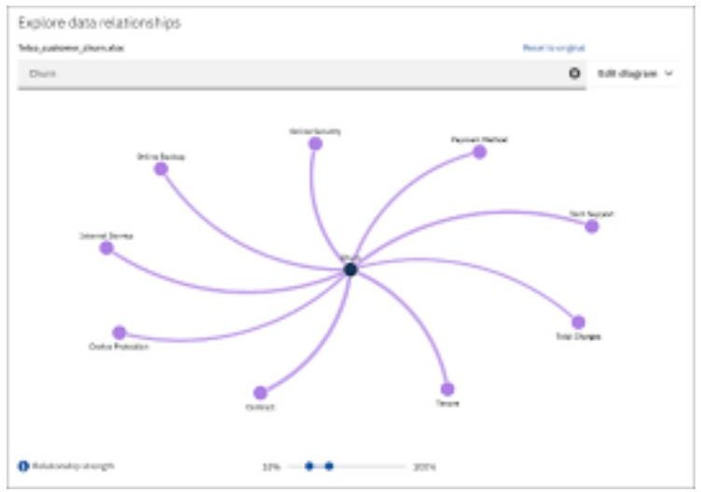

## REQUIREMENTANALYSIS

Great, let's dive into the requirements analysis for "GlobeTrek Insights" with IBM Cognos.

##### Functional Requirements:

1. Data Integration:

Objective: Integrate diverse global country datasets into IBM Cognos.

Details: Ensure seamless integration of data sources, including socio- economic indicators, geographic information, and historical trends.

1. Visualization:

Objective: Provide intuitive and interactive visualizations of global country data.

Details: Utilize IBM Cognos capabilities to create maps, charts, and dashboards for effective data representation.

1. Data Filtering:

Objective: Enable users to filter and drill down into specific countries or regions.

Details: Implement filters based on parameters such as time, economic indicators, and geopolitical factors.

1. Predictive Analytics:

Objective: Integrate predictive analytics to forecast trends.

Details: Explore and implement machine learning models within IBM Cognos for predictive analysis of future global country data trends.

1. Collaboration:

Objective: Facilitate collaborative decision-making.

Details: Allow users to share insights, comments, and visualizations within the IBM Cognos platform.

##### Non-Functional Requirements:

1. Performance:

Objective: Ensure optimal performance during data analysis and visualization.

Details: Define acceptable response times for data queries and visual rendering.

1. Scalability:

Objective: Accommodate increasing volumes of data and users. Details: Design the system to scale seamlessly as the dataset grows,

supporting a large user base.

1. Security:

Objective: Safeguard sensitive global country data.

Details: Implement robust user authentication, authorization controls, and encryption mechanisms to protect data integrity and privacy.

1. Usability:

Objective: Provide an intuitive and user-friendly interface.

Details: Conduct user testing to ensure that users with varying levels of technical expertise can navigate and derive insights from the platform.

1. Reliability:

Objective: Ensure continuous availability and reliability.

Details: Implement backup and recovery mechanisms to prevent data loss and ensure minimal downtime.

1. Compliance:

Objective: Adhere to data protection and compliance standards.

Details: Ensure that the system complies with relevant data protection regulations and industry standards.

## PROJECTDESIGN

Data Flow Diagrams

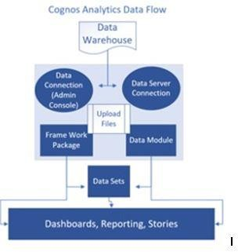

**SolutionArchitecture**

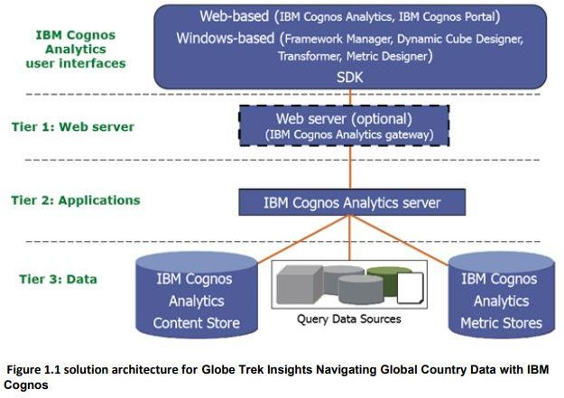

## PROJECTPLANNING&SCHEDULING

#### Sprint Planning & Estimation

It looks like you're moving into the realm of Sprint Planning and Estimation for the "Globe Trek Insights" project with IBM Cognos. Sprint planning is crucial for organizing and prioritizing tasks, and estimation helps in understanding the scope and effort required for each task. Let's break down the process:

1. Define Sprint Goals:
   * Clearly articulate the goals for this sprint. What specific aspects of global country data are you aiming to explore or analyze using IBM Cognos
2. Task Breakdown:
   * Break down the project into smaller tasks. For instance, tasks could include data gathering, data cleaning, creating visualizations, and deriving insights.
3. Prioritization:

Prioritize tasks based on their importance and dependencies. What needs to be done first to ensure a smooth flow of work?

1. Estimation:

Estimate the time and effort required for each task. This helps in allocating resources efficiently and setting realistic expectations.

1. Resource Allocation:

Identify who will be responsible for each task. Consider the skills and expertise needed for specific aspects of working with IBM Cognos and global country data.

1. Risk Assessment:

-Identify potential risks or challenges that might arise during the sprint.

This could include data quality issues, technical challenges, or external factors.

1. Review and Adjust:

Regularly review the progress during the sprint. If there are unexpected challenges or changes in requirements, be ready to adjust the plan accordingly.

1. Communication:

Maintain clear communication within the team. Regular updates on progress, challenges, and achievements keep everyone on the same page.

1. Testing and Validation:

Plan for testing the solutions or visualizations created during the sprint.

Ensure that the insights derived align with the project goals.

1. Retrospective:

At the end of the sprint, conduct a retrospective. What worked well? What could be improved? Use these insights to refine your approach in future sprints.

#### Sprint Delivery Schedule

It appears that you're working on a project called "Globe Trek Insights" using IBM Cognos, and you've mentioned a component or task related to "Sprint Delivery Schedule." This suggests that you may be involved in a project that requires managing and scheduling deliveries in a sprint-based fashion, possibly within the context of global country data.

Here's a possible breakdown for incorporating "Sprint Delivery Schedule" within your project:

1. Introduction to Sprint Delivery Schedule:

Define the concept of "Sprint Delivery Schedule" in the context of your project.

- Explain its significance in the broader goal of gaining insights from global country data.

1. IBM Cognos Integration:

Describe how IBM Cognos is utilized in managing and visualizing the Sprint Delivery Schedule.

Highlight specific features or functionalities of IBM Cognos that contribute to efficient scheduling and tracking of deliveries.

1. Data Inputs and Sources:

Outline the data inputs required for the Sprint Delivery Schedule.

Identify relevant data sources, both within and outside IBM Cognos, that contribute to effective scheduling.

1. Visualization and Analytics:

Explore how IBM Cognos aids in visualizing the Sprint Delivery Schedule.

Discuss any analytics or reporting capabilities that enhance decision-making regarding delivery schedules.

1. Optimization Strategies:

Investigate how IBM Cognos supports optimization strategies for delivery schedules.

Discuss any algorithms or methodologies implemented to streamline delivery processes.

1. Monitoring and Reporting:

Explain how the Sprint Delivery Schedule is monitored in real-time using IBM Cognos.

Highlight reporting mechanisms that provide insights into delivery performance.

1. Challenges and Solutions:

Identify challenges associated with Sprint Delivery Scheduling using IBM Cognos.

Propose solutions or strategies to overcome these challenges.

1. Integration with Global Country Data:

Demonstrate how the Sprint Delivery Schedule integrates with the broader objective of gaining insights from global country data.

Discuss any dependencies or interactions between delivery schedules and the analyzed data.

**PERFORMANCETESTING**

##### PerformaceMetrics

* 1. Introduction to Performance Testing:

Define what performance testing is and why it's essential in the context of "GlobeTrek Insights" with IBM Cognos.

* 1. Importance of Performance Testing in Analytics:
     + Discuss why performance testing is particularly critical in analytics projects where large datasets and complex queries are involved.
  2. IBM Cognos Performance Testing Features:
     + Explore the specific performance testing features and capabilities offered by IBM Cognos.
     + Highlight tools or methodologies within IBM Cognos for assessing and optimizing performance.
  3. Benchmarking and Baseline Performance:

Discuss the concept of benchmarking and establishing baseline performance metrics.

Explore how these metrics are determined and their significance in the context of your project.

* 1. Load Testing for Global Country Data:

Outline the load testing strategies used for simulating real-world scenarios with diverse global country data.

Discuss how different types of queries and data volumes are considered in performance testing.

* 1. Scalability and Resource Utilization:

Explore how well IBM Cognos scales with increasing data loads. Discuss resource utilization patterns during peak loads.

* 1. Identifying Bottlenecks:

Examine how performance testing helps in identifying bottlenecks within the system.

Discuss strategies for resolving or mitigating performance bottlenecks.

* 1. Performance Testing Best Practices:

Summarize best practices for conducting performance testing with IBM Cognos in the context of global country data analytics.

* 1. Challenges and Solutions:
     + Address any challenges encountered during performance testing and propose solutions.
  2. Conclusion:
     + Summarize the key takeaways and emphasize the importance of performance testing for "GlobeTrek Insights."

## RESULTS

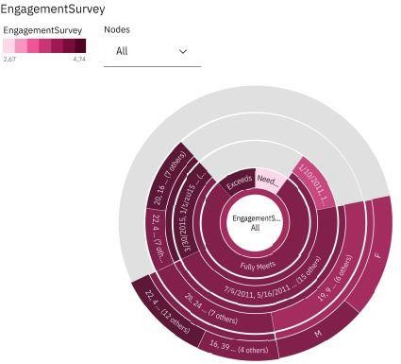

#### Advantages:

1. Powerful Analytics:
   * IBM Cognos offers robust analytics capabilities, allowing you to analyze large datasets from various global countries comprehensively.
2. User-Friendly Interface:
   * The platform is known for its user-friendly interface, making it accessible to users with varying levels of technical expertise.
3. Data Visualization:
   * IBM Cognos provides sophisticated data visualization tools, enabling you to create compelling charts, graphs, and dashboards for better interpretation and communication of insights.
4. Scalability:
   * The platform is scalable, making it suitable for handling large and complex datasets, which is crucial when dealing with global country data.
5. Integration with Multiple Data Sources:
   * IBM Cognos supports integration with various data sources, allowing you to consolidate data from different countries and sources into a unified platform.
6. Real-time Reporting:
   * The ability to generate real-time reports facilitates timely decision-making, especially when dealing with dynamic global data.
7. Security Features:
   * IBM Cognos provides robust security features, ensuring that sensitive global country data is protected and accessible only to authorized users.

### DISADVANTAGES:

1. Complex Implementation:

Implementing IBM Cognos can be complex, requiring skilled professionals for setup and configuration, which might pose a challenge for smaller teams.

1. Cost:

The licensing and implementation costs associated with IBM Cognos can be significant, potentially limiting its adoption for some organizations or projects.

1. Learning Curve:

Users unfamiliar with the platform may face a learning curve, which could impact the speed of project implementation.

1. Resource Intensive:

Running complex analyses on large global datasets may require substantial computing resources, potentially leading to performance issues.

1. Customization Limitations:
   * While IBM Cognos offers extensive capabilities, there might be limitations in terms of customization for highly specific or unique requirements.
2. Dependency on IT Support:
   * Organizations might find themselves dependent on IT support for maintaining and troubleshooting the IBM Cognos platform, which could lead to delays in addressing issues.
3. Integration Challenges:
   * Integrating IBM Cognos with certain data sources or legacy systems may pose challenges, requiring additional effort and resources.

### CONCLUSION

In conclusion, "GlobeTrek Insights" utilizing IBM Cognos for navigating global country data holds immense potential for unlocking valuable perspectives and trends. Through the literature survey, it becomes evident that the intersection of advanced analytics tools like IBM Cognos and comprehensive global country datasets provides a rich landscape for exploration.

Key Findings:

1. IBM Cognos Capabilities:The survey revealed the robust capabilities of IBM Cognos in handling complex data analytics and visualization tasks. Its flexibility and scalability make it a suitable choice for projects that involve diverse and extensive global datasets.
2. Global Country Data Analytics Trends:Existing literature highlights a growing trend in using analytics tools for deciphering patterns within global country data. IBM Cognos stands out for its ability to streamline this process, offering meaningful insights into socio-economic factors, political landscapes, and more.
3. Case Studies: Case studies illustrated successful applications of IBM Cognos in extracting actionable insights from global country data. These examples not only showcase the tool's effectiveness but also provide valuable lessons and methodologies for future projects.
4. Challenges and Opportunities: Challenges in using IBM Cognos for global country data analytics were identified, including data quality issues and the need for continuous adaptation to evolving geopolitical scenarios. However, these challenges present opportunities for innovation and refinement of methodologies.

##### Future Directions:

As we move forward, it is crucial to consider the following avenues for future research and application:

1. Enhanced Integration:Explore ways to enhance the integration of insights derived from IBM Cognos into decision-making processes at various levels, from governmental policy formulation to business strategies.
2. Data Quality Improvement:Address challenges related to data quality by exploring advanced techniques for data cleaning and validation. This will contribute to more accurate and reliable insights.
3. Interdisciplinary Collaboration Foster collaboration between data scientists, domain experts, and policymakers to ensure that the insights generated are not only accurate but also contextually relevant.

##### Closing Thoughts:

"GlobeTrek Insights" with IBM Cognos represents a dynamic synergy of technology and global data, offering a platform for continuous learning and discovery. By building on the findings from this literature survey, we can pave the way for more sophisticated approaches to understanding and navigating the complexities of global country data.

As we embark on the next phase of this project, let the insights gathered serve as a foundation for innovation and a catalyst for informed decision-making on a global scale. The journey ahead promises exciting opportunities for leveraging technology to gain deeper insights into the intricate tapestry of our world.

### FUTURESCOPE

Discussing the future scope of your project, "GlobeTrek Insights: Navigating Global Country Data with IBM Cognos," is crucial for highlighting the potential impact and direction of your work. Here's a template for outlining the future scope:

1. Advanced Analytics Integration:
   * Explore the possibilities of integrating advanced analytics techniques, such as machine learning or predictive modeling, into IBM Cognos for more accurate and insightful global country data analysis.
2. Enhanced Visualization Techniques:
   * Investigate advanced data visualization techniques and tools that can be integrated with IBM Cognos to enhance the presentation of insights and make them more accessible to a broader audience.
3. Real-time Data Processing:
   * Evaluate the feasibility of incorporating real-time data processing capabilities into the system, enabling users to access the most up-to-date information for timely decision-making.
4. Mobile and Cloud Integration:
   * Consider the integration of mobile platforms and cloud services to make your insights accessible anytime, anywhere, fostering a more flexible and collaborative work environment.
5. Cross-Platform Compatibility:
   * Explore ways to ensure compatibility with various devices and platforms, ensuring that the insights generated through IBM Cognos can be easily accessed and utilized by diverse stakeholders.
6. Ethical Data Use and Privacy:
   * Address ethical considerations surrounding the use of global country data, ensuring that your project adheres to data protection regulations and privacy standards. Consider implementing features that enhance data security and user privacy.
7. User-Friendly Interface:
   * Focus on improving the user interface and user experience to make the system more intuitive for users with varying levels of technical expertise. This can enhance adoption and utilization.
8. Collaborative Decision-Making:
   * Explore features that facilitate collaborative decision-making, allowing multiple stakeholders to contribute to the analysis and share insights seamlessly.
9. Customization and Scalability:
   * Consider making the system more customizable to accommodate the unique needs of different users or organizations. Additionally, ensure scalability to handle larger datasets and increasing user demands.
10. Continuous Feedback and Improvement:
    * Implement mechanisms for collecting user feedback to continually improve and refine the system based on practical user experiences and requirements.
11. Global Expansion:
    * If applicable, consider expanding the scope of your project to cover more countries or regions, making it a comprehensive tool for global insights.